Qualys

Exam 2.0

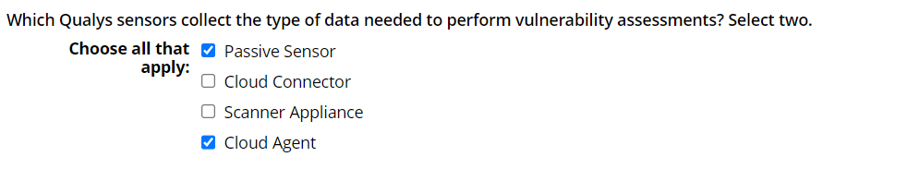

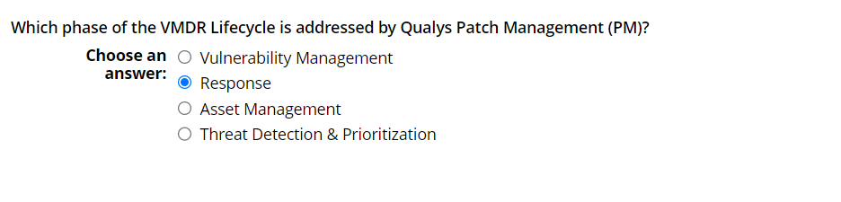

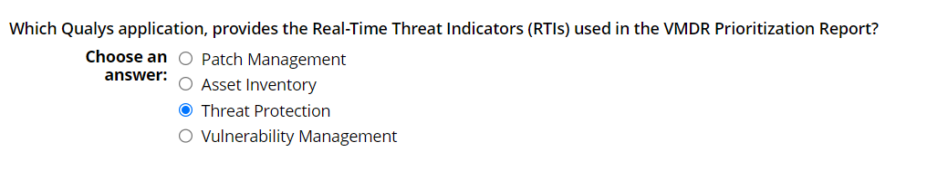

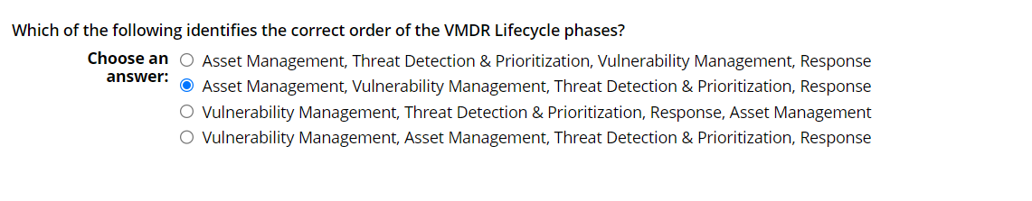

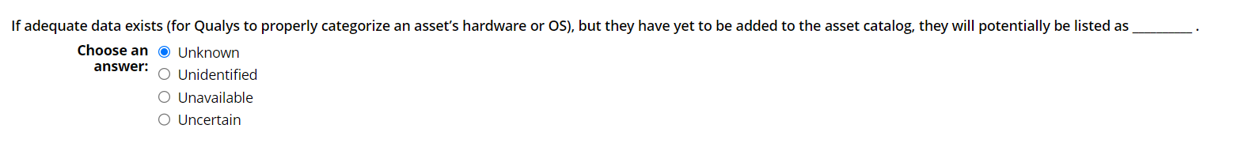

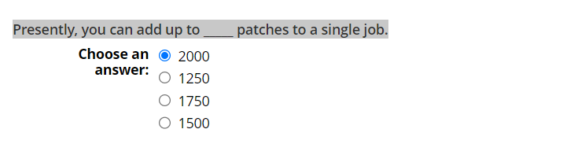

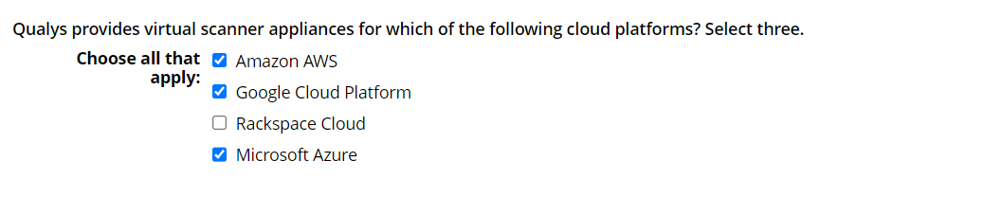

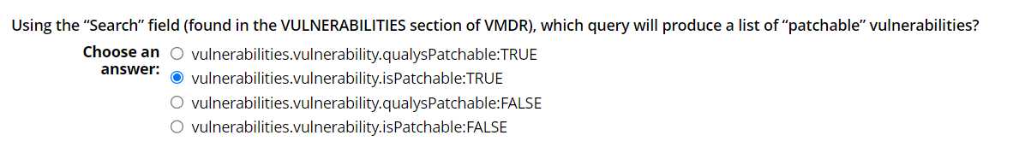

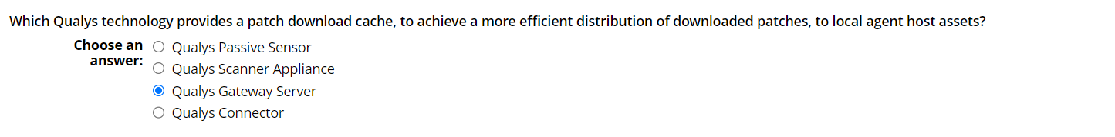

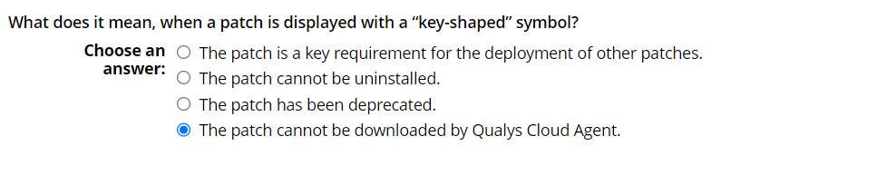

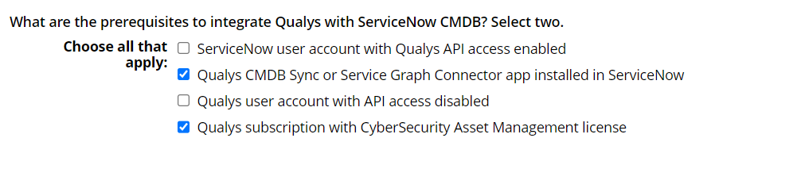

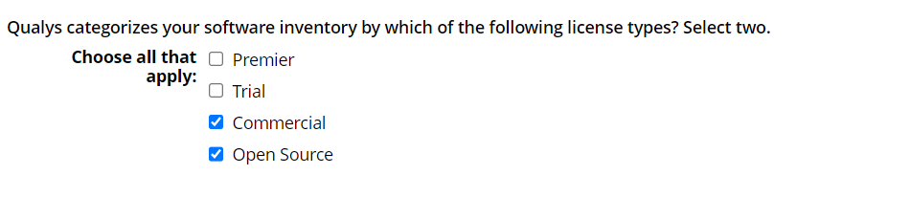

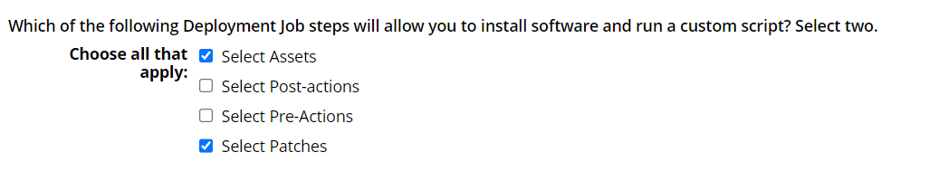

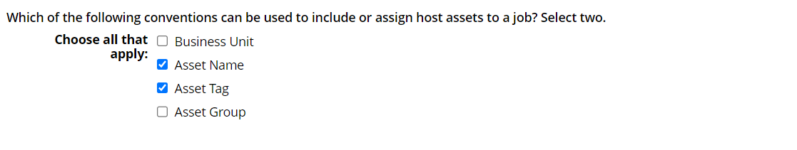

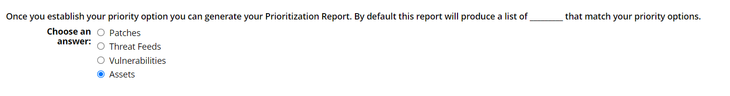

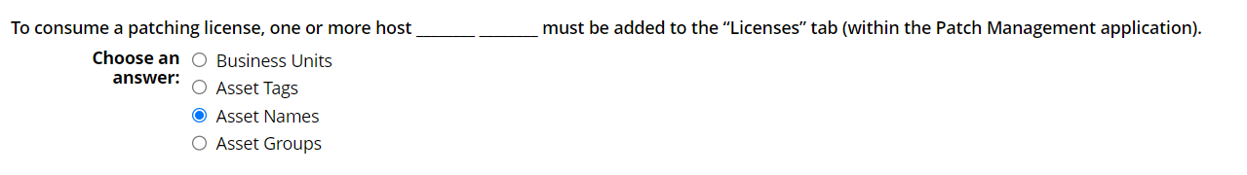

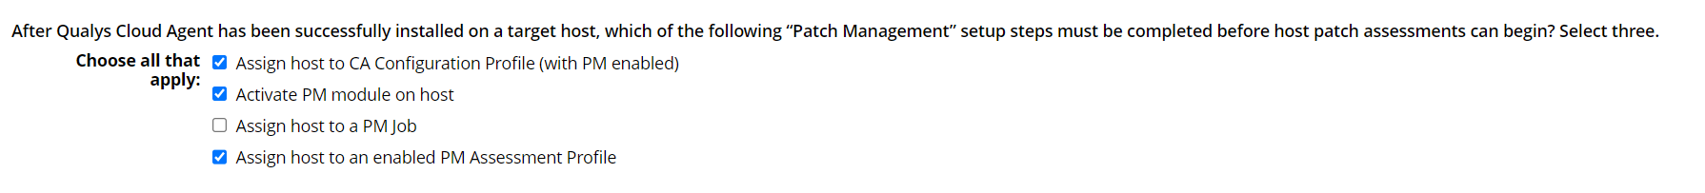

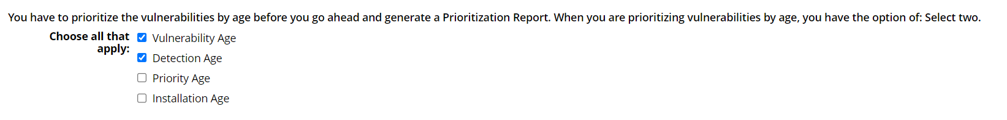

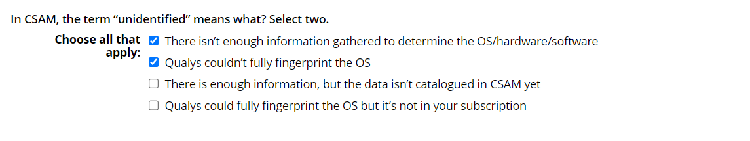



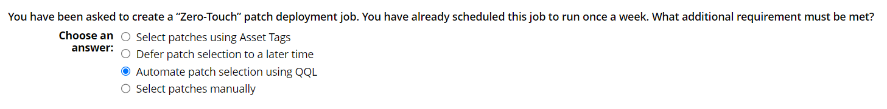

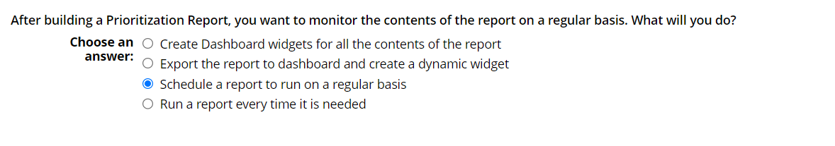





25

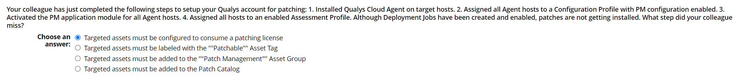

26



27

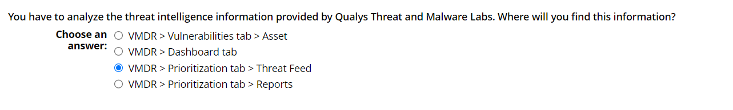

28

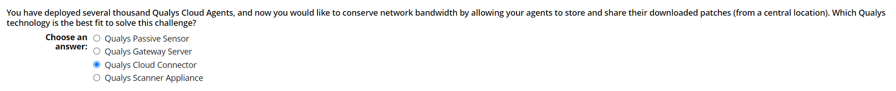

29



30

